

NUST Business School

MGT 752 – Operational Research
End Semester Project Proposal

Submitted to;
Dr. Naveed Ahmed
Submitted by;
Moaiz Irfan (00000536800)
Aafia Khan (00000536690)
Umar Alvi (00000537068)
Muhammad Shehryar Amjad (00000536774)

MBA2K25 – B

Date:

Introdction:
Care Cosmetics is a prominent beauty brand which was founded in 1984 by Asghar Habib who is the chief financial officer at Care Cosmetic group and has done remarkable work to make Care Cosmetic a top brand in Pakistan's beauty and personal care sector. Over the years, the company has built a powerful reputation based on its strong commitment to quality and customer satisfaction. It has a diverse product portfolio which encompasses all type of skincare, body care, hair care, and baby care products. Care Cosmetics responds to a wide range of customer base, positioning itself as a go-to choice for customers who belong from various demographics.
Care Cosmetics is renowned for its philosophy centered around self-care and natural beauty, emphasizing the use of 100% natural, plant-based ingredients in its formulations. This approach not only fosters healthy skin but also resonates with an increasing consumer demand for environmentally and socially responsible products. The company is guided by its slogan, "Caresay Behtr Kya” encapsulating its dedication to enhancing the well-being and beauty of its customers.
In addition to its extensive product range, Care Cosmetics is notable for its commitment to sustainability and corporate responsibility. The company aims to minimize its environmental footprint by adhering to international environmental protocols and implementing green manufacturing practices, including the use of solar energy in its operations.
Objectives:
The primary purpose of this research project is to
1. Identify the key operational challenges faced by Care Cosmetics in production and distribution areas.
2. Apply appropriate Operational Research technique to suggest data-driven solutions for the identified issues.
3. Make suitable recommendations for enhancing operational efficiency but focusing on cost effectiveness and profit maximization.
Problem Statement
Due to highly volatile fuel prices and underdeveloped transportation infrastructure in Pakistan, the operational hurdle is far worse due to high transportation and logistics costs. The main issue Care Cosmetics encountered is the high transportation cost because of the stringent requirements of some of the skin care products. As it is a personal care and skin care manufacturing brand, many products have a stringent requirement of controlled environment shipment that needs specialized temperature-controlled transport and specialized handling, which is often expensive than normal transportation because the mishandling of such products can cause huge profit losses.
Apart from logistics, the increasing raw material cost is also negatively influencing the profit margins, and it is becoming hard for care cosmetics to keep up with the market rates. As due to the rise in inflation, consumers buying power has already significantly reduced, and consumers are choosing alternate brands that are providing products at much cheaper rates while they claim their product to be of higher quality, although in reality they get their product in the market by bypassing safety tests, hence putting their consumers at a risk.
This whole situation has created a challenge for care cosmetics to keep a balance in increasing production cost and control on retail prices without losing its budget conscious customers while delivering high quality products to maintain its profit margins for sustainability of company.
Methodology
This research follows mix-methodology utilizing both qualitative and quantitative methods to answer the same overarching research problems. The goal is to gather and integrate both types of data.
1. Interviews with Senior Managers: Semi-structured interviews were conducted with the production managers, logistics coordinators, and marketing heads, to gain insights about the operational challenges and current practices at Care Cosmetics.
2. Secondary data review: Review existing documentation, including production reports, inventory logs, and financial statements, to gather quantitative data on operational performance.
3. Data Analysis & Application of OR Techniques: Analyze collected data and apply Operations Research techniques such as Unbalanced Transportation Model, and Linear Programming Model to identify optimal solutions for operational problems.
Linear Programming Model
The main aim of any business is to maximize its wealth and increase its revenue. Based on our discussion with senior operation management of Care Cosmetics. The main issue we identified is that they are not making enough profits in their major product line. Due to faster increase in transportation, ingredients and packaging cost of cosmetics, the overall product cost enhances than its sales hence profit issue occurs in cosmetics industry. Sometimes due to the wrong sales forecast, a lot off products go to wastage due to overproduction which can further decrease the profit margin. To overcome this issue Linear Programming Model came into play. It was George Dantzig who is recognized as the creator of Linear Programming Model. But there are certain challenges which they mentioned, like manufacturing cost does not exceed the maximum limit of 55% and distribution cost does not exceed the limit of 25% of average cost. Following data was provided by the head of Operational department.
Prices of their product range
- Lotions: Rs 250-1200 depending on sizes
- Facewash: Rs 500 per unit
- Moisturizers: Rs 150-600 per unit
Standardized production
Product Range | Standard Size
Moisturizing Cream | 100ml jar
Lotion | 200ml bottle
Face wash | 150ml tube
Anti-Aging Serums | 30ml bottle

Raw material consumption per unit
Product | Emulsifiers | Oils | Actives | Water
Moisturizer | 0.01 kg | 0.03 kg | 0.005 kg | 0.055 kg
Lotion | 0.015 kg | 0.04 kg | 0.006 kg | 0.12 kg
Face Wash | 0.02 kg surfactants | 0.005 kg | 0.004 kg | 0.11 kg
Serum | 0.003 kg | 0.004 kg | 0.012 kg | 0.011 kg

Water Usage
Product | Water Usage
Moisturizer | 0.06L
Lotion | 0.13L
Face Wash | 0.12L
Serum | 0.015L

Machine time requirements
Total machine time is obtained after adding filling time and mixing time
Product | Total Machine Time
Moisturizer | 3.2 min/unit
Lotion | 3.8 min/unit
Face Wash | 2.6 min/unit
Serum | 5.7 min/unit

Based on all this information a linear programming model was developed and solved using excel solver.
Decision Variable
X₁= Moisturizer
X₂= Lotion
X₃= Face Wash
X₄= Serum
Objective Function
Maximize Z = 115x₁ + 165x₂ + 185x₃ + 420x₄
Model Constraints
Manufacturing cost constraint
205x₁ + 285x₂ + 315x₃ + 780x₄ <= 55000
Labor hr. per unit constraint
0.045x₁ + 0.050x₂ + 0.035x₃ + 0.070x₄ <= 23hrs/unit
Machine time Requirement
3.2x₁ + 3.8x₂ + 2.6x₃ + 5.8x₄ <= 45 min/unit
Water usage
0.06x₁ + 0.13x₂ + 0.12x₃ + 0.015x₄ <= 19ml/ unit
Non-negativity Constraints
It’s important to mention non-negative constraint while solving the mathematical model, because value of lotion, moisturizer, serum, and facewash can never be zero or negative number, they must always be in positive number.
x₁ + x₂ + x₃ + x₄ >= 0
Solver Setup
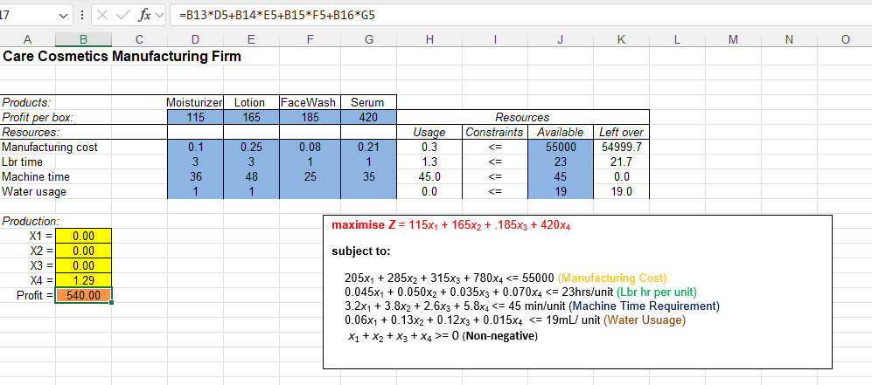
Objective Function
B13*D5+B14*E5+B15*F5+B16*G5

From the above-mentioned picture you can clearly see the values of moisturizer, lotion, facewash, and profit. All these values are contained in cells B13, B14, B15, B16 and B17 respectively. For Instance, in cell H6 we have used the formula B13*D7+B14*E7+B15*F7+B16*G7 and the similar formula used for other cells to till cell H9. The <= signs used in cells I6, I7, I8 and I9 respectively are for cosmetic purpose only these signs have no real impact.
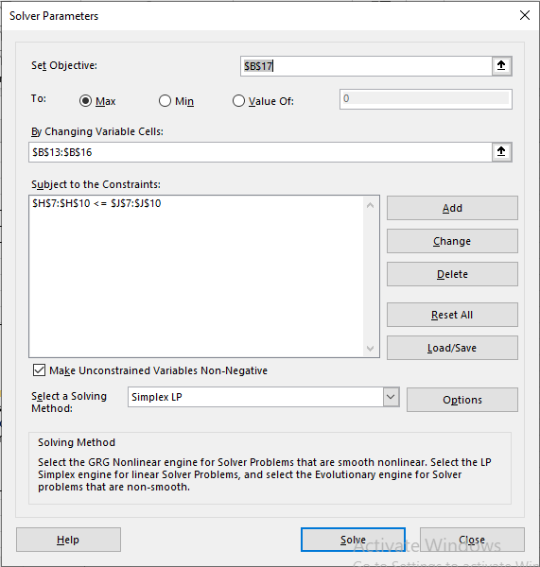
While solving this problem on excel solver first set the objective function. In this example the objective function is cell $B$17. After that excel solver will indicate two possibilities weather you want to maximize or minimize the objective function. Select maximize option. After that press Add to add constraints. In this case our constraint is shown on the picture inserted above. Once the constraint is added press on the Solve icon the Solver will solve the problem. Solver will ask for the method than here choose Simplex Linear Programming. This will make sure that excel solver will only use the simplex method not any other numerical technique to solve the maximization problem.
In real business scenario, care honey lotion is a top selling product, but the mathematical model reveals that serum is also a most purchased product and Anti-aging serum is generating maximum revenue while using limited resources.
Transportation Model
In any type of the business there are two main types of cost is involved; Fixed Costs and Variable Costs that businesses incur to distribute the products and to sell the products in the market. For the cosmetic sector, Variable cost includes the cost of raw material, transportation cost, packaging, fuel and electricity charges. Fixed charges include rent of factories, machines maintenance cost and salaries of permanent employees. So, for an organization the main goal is to control the Variable cost to maximize the profit.
So, to minimize the transportation cost, a transportation model for Care Cosmetics is devised to transport products from various sources (Multan and Lahore) to destinations (Islamabad, Peshawar, Karachi, and Faisalabad) to fulfill the needs of the customers. The goal of transportation is to produce products at supply locations and transport them to destination where these products are demanded at minimum cost. The origin is 2 production plants located at Multan and Lahore with the capacities of 18,000 units and 15,000 units respectively while the destinations are 4 distribution centers with demand of 8,500 units, 6,000 units, 4,000 units and 4200 units, respectively. Each source can supply a fixed number of products, but each destination has a demand that must be met. The cost of transporting a unit of serum, moisture, lotion, and facewash is listed here.
Source | Islamabad | Karachi | Faisalabad | Peshawar
1.Multan | 25 | 35 | 30 | 30
2.Lahore | 20 | 50 | 20 | 40
For instance, it costs 25Rs to transport one unit of serum or facewash to deliver from Multan to Islamabad and similarly the transportation of shipping serum or lotion from Lahore to Peshawar is 40Rs. So here in this scenario, Vogels Approximation method is used to find the initial feasible solution for the Transportation model.
Objective function:
Min Z= 25x_{1a}+35x_{1b}+30x_{1c}+30x_{1d}+20x_{2a}+50x_{2b}+20x_{2c}+40x_{2d}
Decision Variable
X_{ij} = I for source and J for destinations
Model Constraints
Since this is an unbalanced transportation model as supply is greater than demand so supply comes with inequality and demand with equalities.
It is a Type-2 Problem: Supply>Demand
Supply Constraints (Inequalities)
X_{1a}+X_{1b}+X_{1c}+X_{1d}< 18,000 units
33,000 units
X_{2a}+X_{2b}+X_{2c}+X_{2d}< 15,000 units
Demand Constraints (Equalities)
X_{1a}+X_{2a} = 8,500 units
X_{1b}+X_{2b} = 6,000 units
22,700 units
X_{1c}+X_{2c} = 4,000 units
X_{1d}+X_{2d} = 4,500 units
X_{ij} > 0 (Non-Negativity Constraint)
Analysis & Findings for Optimal Transportation Cost
The model will be solved using excel solver by setting the objective function to “Minimum” and by changing the variable cells as decision variables lie in the cell B3:E4. The transport model formed with the cells acts as a rudiment that defines pre-unit transportation cost from supplier to destination where demand is to be fulfilled with the optimized transportation cost.
 | Islamabad | Karachi | Faisalabad | Peshawar | Supply
Multan | 25 | 35 | 30 | 30 | 33,000
Lahore | 20 | 50 | 20 | 40 | 22,700
Demand | 8,500 | 6,000 | 4,000 | 4,200
The first picture (M1) is the original matrix of the per unit cost and the second one (M2) gives the optimized cost using specific transportational channels
 | Islamabad | Karachi | Faisalabad | Peshawar | Supply | Units supplied
Multan | 0 | 6000 | 0 | 1700 | 18,000 | 7700
Lahore | 8500 | 0 | 4000 | 2500 | 15,000 | 15000
Demand | 8,500 | 6,000 | 4,000 | 4,200
Units demanded | 8500 | 6000 | 4000 | 4200
Optimal Cost | 611000

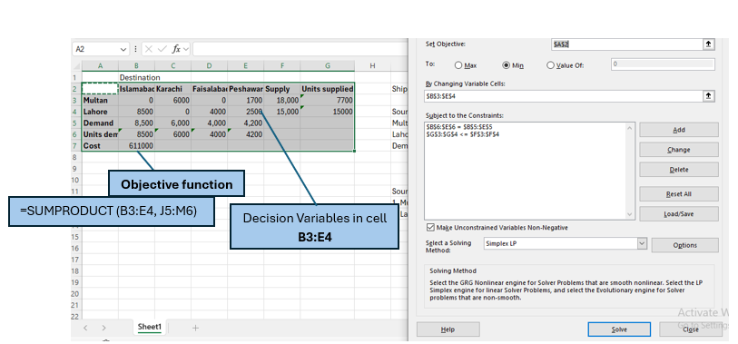
The optimal units that can be transported from Multan is “0” units to Islamabad, 6000 units to Karachi and 1700 units to Peshawar. From Lahore, 8500 units, 0 units, 4000 units and 2500 units respectively can be transported to Islamabad, Karachi, Faisalabad, and Peshawar. Approximately 611,000 would be the total logistics cost of the cosmetics industry for transporting cosmetics products from Multan & Lahore to other capital cities including Karachi, Peshawar, Islamabad, and Faisalabad.

Recommendations
Regional Distribution Centers:
Care Cosmetics should establish small warehouses in major cities like Islamabad, Peshawar and Karachi instead of delivering everything from a central hub (Multan, Lahore) to minimize the cost and distance thus improving customer service. By establishing regional distribution networks Care Cosmetics distributors can overcome the issue of stock-outs during peak hours, thus ensuring fast delivery within 24-48 hours.
Route Optimization Software:
Transportation Management Systems utilize Machine Learning and Deep Learning algorithms should be implemented to lower fuel consumption and to plan the most fuel-efficient delivery routes. With the implementation of TMS companies can save 5-15% on transportation costs by lowering fuel consumption. The main advantage of using Transportation Management System is that Care cosmetics can lower its carbon footprint by 8-10% by cutting unnecessary mileage.
Insulated Packaging Innovations:
Some of the skin care products are heat and light sensitive and these products require refrigerated trucks to be delivered from source to destination. By establishing Regional Distribution Centers, companies can save the expenses which need to be spent on refrigerated trucks and can also lower the risk of wastage.
Battery Operated Vehicles
Solar-Powered Vehicles Replace aging vehicles with battery operated solar vehicles with GPS-trackers attached to fleet to lower the transportation cost. As solar panels attached to the roof of the vehicles convert solar energy into electrical energy thus reducing the need of petroleum or diesel-based fuels and it also saves the time which is spent on charging.

